CASE STUDY
Client Case Study: Patrick Mahomes & The 15 and the Mahomies Foundation
You are a team of young analysts working at an asset management company. The firm manages a diversified portfolio currently worth $100,000,000.
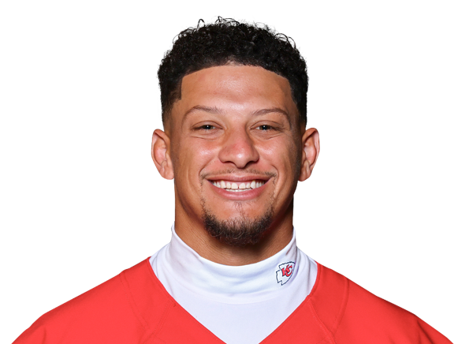
Your portfolio manager recently met with a potential client, Patrick Mahomes of the 15 and the Mahomies foundation, who needs the firm’s help achieving some specific investment goals discussed below. Your team hopes to shape the winning investment strategy that Patrick and 15 and the Mahomies foundation ultimately choose to make a lasting community impact from an initial $100,000 investment.

Background
Patrick Mahomes is one of the most recognizable athletes in the world. The Kansas City Chiefs quarterback has won multiple Super Bowl championships, earned numerous NFL MVP awards, and signed one of the largest contracts in professional sports history. But to those who know him best, Patrick is more than a football player — he is a community builder, a businessman, and a devoted family man.
Patrick grew up in Tyler, Texas, where he was a multi-sport star in football, baseball, and basketball. His father, Pat Mahomes Sr., played Major League Baseball, and Patrick inherited both his athletic ability and his competitive drive. He attended Texas Tech University, where he became one of the most electrifying quarterbacks in college football history before being selected 10th overall in the 2017 NFL Draft.
Off the field, Patrick has built an impressive business portfolio. He holds equity stakes in the Kansas City Royals (MLB), Sporting Kansas City (MLS), and several consumer brands. He is married to Brittany Mahomes, a former professional soccer player and entrepreneur, and the couple has three young children. Patrick also has a younger brother, Jackson, and maintains deep ties to his hometown of Tyler, Texas.
"I want to use my platform to make a real difference — not just on the field, but in people's everyday lives." — Patrick Mahomes

The 15 and the Mahomies Foundation
In 2019, Patrick established the 15 and the Mahomies Foundation, named after his jersey number. The foundation is dedicated to improving the lives of children by focusing on health, wellness, communities in need, and education. Since its founding, the foundation has donated millions of dollars to communities across Kansas City and his home state of Texas, funding youth athletic programs, food security initiatives, and disaster relief efforts.
Patrick recently met with your portfolio manager. He is looking for a trusted team of analysts to help him manage $100,000 in foundation funds to achieve two specific financial goals. He has separate financial advisors managing his personal wealth and retirement planning, so you should focus exclusively on these two foundation goals.
Patrick made it clear that because these are foundation funds — money meant to serve communities and children — the portfolio should be managed responsibly. He is not looking to gamble on speculative or highly volatile investments. He wants steady, thoughtful growth.
"Every dollar in this foundation belongs to the kids we serve. I need a team I can trust to treat it that way."
Patrick's Two Financial Goals
Goal 1 — The Mahomies Youth Sports Fund (Mid-Term Goal)
Patrick is passionate about ensuring that kids in underserved communities have access to youth sports, which he credits as one of the most formative parts of his own development.
He wants to launch a Mahomies Youth Sports Fund that will distribute $8,000 per year in grants to youth athletic programs, beginning in 2026 and running for at least 6 consecutive years (through 2031). These grants will cover equipment, facility access, and coaching stipends for programs in Kansas City and Tyler, Texas.
Patrick needs your team to develop a plan to fund this $48,000+ in total distributions. Should a portion of the $100,000 be kept in cash? Invested in dividend-paying stocks that generate consistent income each year? A bond strategy? He wants your team to make the case for the best approach and explain why.
Goal 2 — The Mahomies Community Center (Long-Term Goal)
Patrick's biggest dream for the foundation is to open a Mahomies Community Center in Kansas City — a state-of-the-art facility that will serve as a permanent hub for youth programming, mentorship, workforce training, and wellness services for families in the community.
Construction of the center is expected to begin in 2035. Patrick estimates that the foundation's contribution toward construction and the first year of operations will need to be at least $60,000. He would like your team to grow the remainder of the $100,000 portfolio — after funding Goal 1 — aggressively enough over the next 10+ years to meet or exceed this target.
Patrick has mentioned that he is particularly interested in companies and sectors that align with the foundation's values, including healthcare, technology, consumer brands, and sports/entertainment. However, he ultimately defers to your team's expertise on the final investment decisions.
"I want the foundation to be here long after I've retired. Build something that lasts."

Your Challenge
Your team has 6 weeks to develop an investment strategy that meets both of Patrick's goals. You will:
- Spend Week 1 studying the case study and developing your strategy plan
- Allocate the $100,000 portfolio between Goal 1 (the annual youth sports grants) and Goal 2 (the community center fund)
- Select stocks and/or ETFs that reflect a thoughtful, responsible strategy aligned with Patrick's values
- Actively manage your virtual portfolio on the trading simulator during Weeks 2–5
- Use Week 6 to write and submit your 6-page final report explaining your strategy and how it serves Patrick and the 15 and the Mahomies Foundation
At the end of the competition, judges will evaluate not just your returns — but whether your strategy truly reflects what Patrick asked for. The best team won't just make money. They'll make a case Patrick can believe in.

